Sherbet Kitten by Sherry M. (CHIWALUV AMIGURUMI CRITTERS)

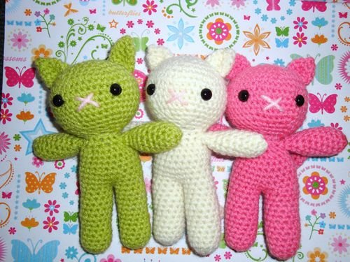
Materials List
Materials Needed:
Redheart "Designer Sport": lime, pink, white, or color of choice.
Crochet hook #D
Polyester Fiber Fill
Yarn Needle
9mm plastic eyes
scissors

Notes
Stitch Abbrvs: FO = fasten off, BLO = back loop only

The Pattern
RULES You need to follow to sell items made from this pattern:
1. Post your finished item for sale
2. Post link to my blog - (http://chiwaluvchis.blogspot.com/)
3. Post Who wrote the pattern - (Chiwaluv Amigurumi Critters)
4. Post credit to - ( www.Chiwaluv.etsy.com)
5. DO NOT SELL THE PATTERN ITSELF!
6. DO NOT TRANSLATE INTO ANOTHER LANGUAGE!
7. DO NOT change the pattern or build upon it!
****************************************************************
LEGS and BODY: Make 2 in color of choice
Note: Using Polyester fiber fill stuff as you crochet each part
1. Make a magic ring with 6 sc
2. *sc inc 1*, repeat 5 times (12)
3-14. sc 12
15. hold the two legs together and sc around (24)
16-21.sc 24
22. * sc 2, sc dec 1 * repeat 6 times (18 )
23. sc 18, FO lv long yarn tail for sewing head to body
HEAD: Make 1 in color of choice
1. Make a magic ring with 6 sc
2. *sc inc 1*, repeat 5 times (12)
3. * sc 1, sc inc 1 * repeat 6 times (18 )
4. * sc 2, sc inc 1 * repeat 6 times (24 )
5. * sc 3 sc inc 1 * repeat 6 times (30 )
6. * sc 4, sc inc 1 * repeat 6 times (36 )
7. * sc 5, sc inc 1 * repeat 6 times (42 )
8-11. sc around (42)
12. * sc 5, sc dec 1 * repeat 6 times (36 )
13. * sc 4, sc dec 1 * repeat 6 times (30 )
14. * sc 3, sc dec 1 * repeat 6 times (24 )
15. * sc 2, sc dec 1 * repeat 6 times (18 )
FO , weave ends in. Sew body to head.
ARMS: Make 2 in color of choice
1. Make a magic ring with 5 sc
2. sc inc 5 times (10)
3-8. sc around (10) add a bit of stuffing for Paw.
(do not stuff all the way up the arm!)
9. *sc dec, sc 4* repeat * to * one more time (8)
10-11. sc 8 FO , lv yarn tail to sew to sides of body
EARS: Make 2 in color of choice
1. Make a magic ring with 3 sc
2. sc inc twice evenly on this roung (5)
3. sc inc 5 times (10)
4-5. sc 10 FO , lv yarn tail to sew to Kittens head
TAIL: Make 1 in color of choice
1. Make a magic ring with 6 sc
2-9. sc around (6)
FO lv yarn tail to sew to back of Kitten body.
OPTIONAL: you may tie a ribbon around your kitten"s neck, or crochet a little
flower to attach to your kitten's head or neck.
"
Hint: I sell little crochet flowers in my Etsy shop, listed under "Gifts and Floral
Bobbles" here:
http://www.etsy.com/shop.php?user_id=6453345&section_id=6155184
HAPPY CROCHETING!

